“Doc, I’m flying next week. How do I take care of my asthma??” ^{®2012}
By Dr. Mac

CHECK THE FOLLOWING.

First - Where are you going? In less polluted areas (North America, Europe, Japan, Singapore)? you will most likely not have any attack and may not need any medication at all - unless it’s pollen season there, or the temperature is on the extremes.

Check epidemics possibly currently occurring in the place of interest. If there is one, wearing mask may help (but you may be suspected of having a dreaded disease, esp in this bird-flu-scared world) . Can you cancel your trip? Check Center for Disease www.cdc.com website if you cant find it in CNN or BBC World.
Second, find out How’s the weather? How will you know? Check your favorite cable TV network. Check pattern. No Cable TV? In the past there are executive diaries which features temperature profiles of several countries. Or you can text your relatives there. You have to find out what to expect when you arrive.

Today’s digital technology allows one to instantly see on the internet and provide even a five-day prediction.

Third, ask "What should you avoid? " Whatever makes you worse here is probably what can also make you worse over there. One thing is certain: Going to less polluted areas may completely relieve you of your symptoms. (For a moment. forget about what’s going to happen as soon as you arrive back here.)
Don’t forget to ask your doctor what to take before you arrive back. One foreign patient castigated the air we breathe and told me " You know you are here (in the Philippines) on touchdown, even with eyes closed!" After my two-week out-of-country vacation, I found out he was right all along. (Talking of murky air, par excellence! Dead molds, mosquitoes, flies, sputum from the houk-tu's and chok-wa's ^{(those who spit anywhere)} , super-high vehicle exhausts, etc)

What activities can you do there?
Do things as you can. (Also, see “Environmental Modulation ...”)

Also, remember that foreign medical care is 5-10x higher than its local counterpart. So it’s best to see your doctor for your maintenance meds and for exacerbations - and bring them all with you (TOGETHER WITH THE PRESCRIPTION)

WHICH DRUG TO USE? You have to WRITE in the RX which meds can give you instant relief from those which don’t. Since you cannot exactly predict what to happen when you arrive in your destination, it is best you are properly covered by your maintenance medications. Which is which? DO NOT FORGET TO BRING YOUR PRESCRIPTION, some PORT OF ENTRY OFFICIALS can MAKE YOUR entry 'MEMORABLE' (because they may even destroy your metal luggage signature logos! I use simple duffle bags!)

See also “All these medications are for my asthma?”, “Steriodophobia ...” .

If you are on inhalers, remember that they can present in different strengths, whether they are rapid relievers or for maintenance. Global market nowadays generally tend to move towards varied strengths of medications and combined bronchodilators and steroids in one inhaler canister.

Bringing nebulizers? Portable ok. How about when you recharge in the hotel ? Check your socket requirement There are different plug outlets in different countries. Get that multiple adapter from the local home depot, or find them at the airport duty-free shops before heading for your hotel. Note that before you can use this, you may also need another adapter for your nebulizer which was converted to local applicability. Remember as well that some adapters allow you to use US or European equipments in Asia, but not necessarily vice-versa.

If your machine has an auto-volt, you’ve may have no problem about power supply needs. But, if it needs to be reset every time you change places of stay, RECHECK SETTING BEFORE PLUGGING WHILE ABROAD. ALSO, DO NOT FORGET TO RESET THE MACHINE TO LOCAL APPLICABILITY WHEN YOU BRING IT BACK!!!!

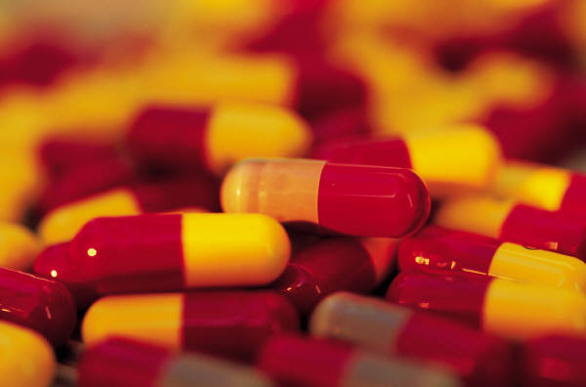
NOW, ANTIBIOTICS. You may have to bring some. In most countries, you cannot get over-the-counter antibiotics other than erythromycins, (and apart from paracetamols and some decongestants). The rest needs at least a 50-75$ consult (make it three or more times if you’re in a hotel). Your doctor will prescribe which will suit your needs.

If in case, you happen to be so short of breath despite your meds, remember 911. Also, remember that if you’re using a cellphone (at least for Motorola) in USA, pressing “1” for a few seconds automatically connects you to 911 service. (I was told its two thousand green bucks per 911 service, wheww!!!!)

Finally, Do you have a comprehensive health insurance coverage? There are local insurance companies that offer reimbursement types, in case you got confined but make sure it includes health, not just accident. Others are more comprehensive. (Schengen states require a P2.5M health insurance cover for each trip). Watch out for Pre-existing conditions? Be prepared. There is no substitute for getting ready of cash or plastic money - just in case.

Don't forget to have those flu vaccine shots, and the pneumonia shots too! At least a month before the trip.

Other than the above, enjoy your stay. Have fun! Diverta! glückliche Reise! Happy trip!

(Oh,, by the way , your doctor collects hats, loves miniature carpentry tools, ,thick black socks, , audiovisual gadgets, etc.) ^{Thank you!}

